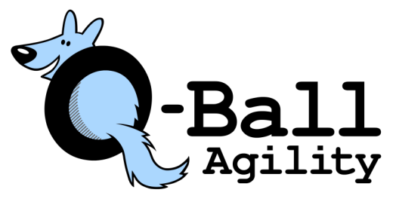
Thank you for entering Q-Ball’s April 2024 trial. We are looking forward to great courses from our judges Tracey Mallinson and Mary Federici. John, Mary and Nicole would like to thank all of you for supporting all our trials and for helping out when needed. This is a very full trial and will need everyone’s to help to keep on schedule!
Payment is now due unless you have already made arrangements with us to pay at the trial.
Please e-transfer funds to qballagility@telus.net
Any withdrawls after the posted closing date are not eligible for a refund or credit except in case of injury or illness.
As always, if you or your dog is feeling ill on the day of the trial, please do not come. We will refund or credit any entries missed because of COVID symptoms or dog sickness/injury.
- No indoor crating
- Dogs may run on plain flat or buckle collar, no attachments.
- No self-serve ribbons. Please see Nicole at the coffee table if you have a Q or title ribbon earned at the trial.
- Running orders and results will be posted in several places. Do not crowd the gate steward.
PARKING: Parking at the front of the building is for judges and hired trial staff only. Competitor parking is on the right hand side of the building. Do not block the driveway of the RV at the back of the lot – it is the parking space for the tenant. Please be considerate and park neatly as close as you can to car beside you. We need to fit many cars in the parking lot.
Please come prepared for the elements and bring your own lunch snacks etc. We will have free coffee and water available.
There are a number of food options within 5-10 min of the barn, or bring your own lunch.
Please note - The blue food table is reserved for judges, paid staff and designated helpers only.
SITE RULES:
- Pick up your dog’s poop. Anyone caught not doing this will be dismissed from the trial with no refund.
- No smoking on the property.
- No excessive barking outside the barn, we do not want the neighbours complaining.
- Due to bylaws and AAC Standards of Conduct we ask competitors to refrain from consuming alcohol during the trial.
If you have not trialed before your dog must be measured by a judge. Measuring will be 7:15 to 7:30 am Saturday morning and before Steeplechase class on Sunday. If you have one measurement on temporary card (dog under 2 yrs) you are good until your dog turns 2 years old. Dogs over 2 need 2 measurements at same height by 2 different judges on your permanent height card.
Familiarization: For Starters Dogs Only – Saturday morning from 7:30 to 7:45 and Sunday before Starter Standard class
First dog is on the line at 5pm Friday and Saturday and Sunday at 8:00 am.
Steeplechase will not begin before 12:00 noon on Saturday and 1:00 pm on Sunday
Course Maps – we will not be printing individual course maps. Maps will be emailed to all competitors by noon on Friday and 4 am on Saturday and Sunday. They will also be posted at the trial.
Any questions, feel free to contact at trialsecretary@q-ballagility.com or Nicole sibercollie13@gmail.com

